# CS 255 System Design Document Template

## UML Diagrams

### UML Use Case Diagram

Modify Packages Date/TIme
Schedule IT (Technical Support) Select Package Password Reset <<Includes>> <<Includes>> <<Includes>> <<Extend>> Administrator Verify Password User Login Phillip Sandoval  |  April 5, 2023 Diagram Key
Use case
Relationship
Employees
Actor
Administrator
IT (Technical Support)
Student <<Extend>> Employees Modify User
Accounts <<Extend>> Course Select <<Extends>> DriverPass Use Case Diagram <<Includes>> Schedule Lessons System Updates Students Password Error
Display System
Maintenance
(Troubleshooting) Take Practice Test
& Quizzes

### UML Activity Diagrams

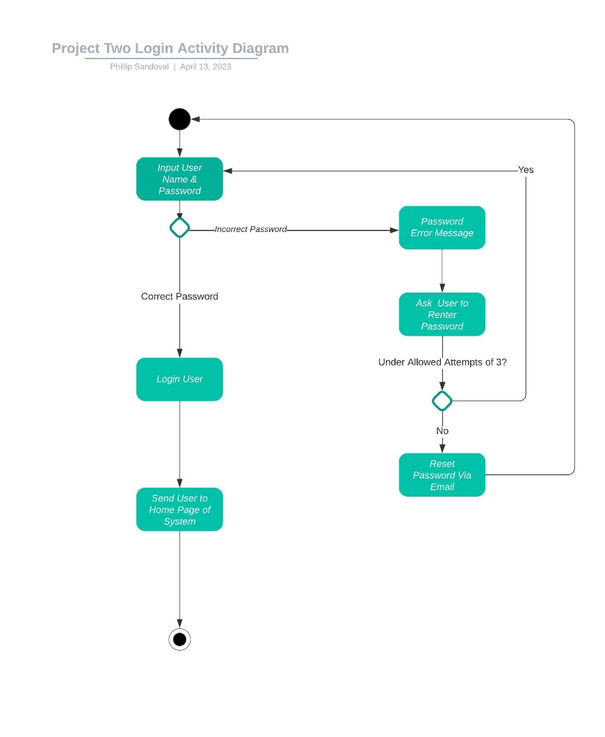

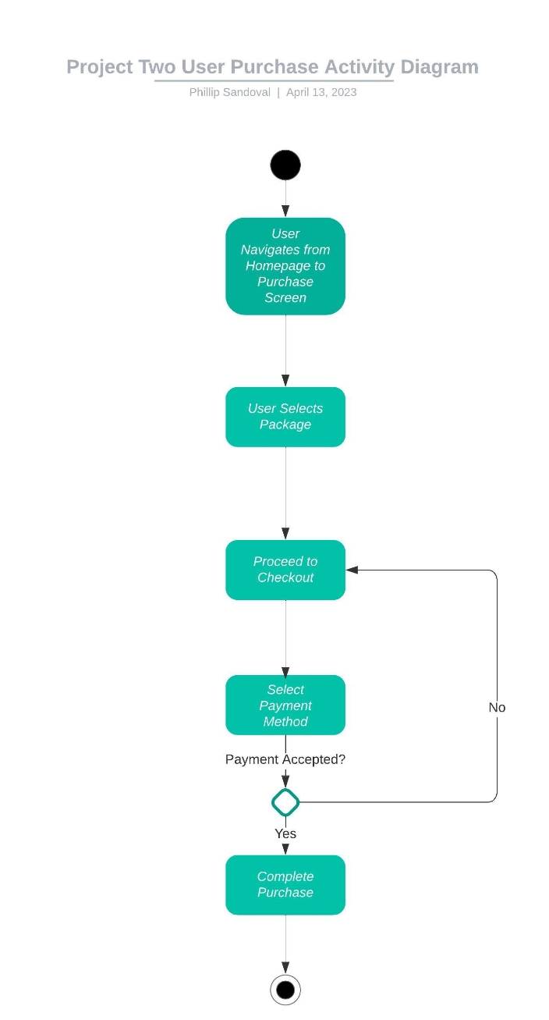

### UML Sequence Diagram

### UML Class Diagram

## Technical Requirements

*Based on the diagrams I have created I can now say that some of the technical requirements of this system would be that the system is needing to be able to be optimal for not only mobile device usage but also be able to run on a laptop and desktop. The DriverPass system must operate on the cloud database to minimize the server upkeep that would need to be done as well. The system created should be fast enough to optimized well enough that any computer would be able to use the system even if the hardware is outdated the user should still be able to access and run the system effectively and efficiently. All users that will be using the system will be required to have a internet connection that is reliable enough to be in use for as long as the system is being used so 8 hours or more and a connection that is sustainable and reliable without losing connection for at least 90-95% since the system will in fact be utilizing the cloud platform.*